Summary for pre-read

WBR - Summary (for Pre-Read)

1) DLD Market
The DLD Sale market value growth has moderated to 19% YoY, with Primary being the growth driver at +38% YoY and Secondary flat at -1% YoY. In terms of volume, Primary saw +18% growth, whereas Secondary decreased by -8%.
2) Commercial
Sales Forecast: AED 55.3M vs 62.6M target (88.4% achievement without Hamptons). March current view ~72% FC WIP with impact of geopolitical context.
3) Demand
SoS: Overall SoS stands at 53.7% (+0.4pp vs Target) as App SoS is at 56.4% (+2.7pp vs Target) and Web SoS is at 49.6% (met Target), while SEO SoS is at 47.4% (-1.2pp vs Target, however saw a MoM increase of +1.6pp)
Exposure LPL: Buy LPL remains in red (same reasons as last time); not a concern as no increased noise from clients regarding RoI. Q2 eLPL targets to be reset to align with actual market growth.
Leads click to delivered: Met Target (+0.3pp) with 84.6% vs target of 84.3%

4) Data Governance: Spam activity removal to be completed on 10th March post which direct and SEO channels can be monitored

5) New Projects (Primary)
New Projects gross revenue ($707.4K) at 22% above target; sold leads at 7.7k (vs 7.9k target)
Media & Developers sales overachieved by 56% in February (Aldar contract for 1.8M AED). YTD: 24% above sales target. March forecast at 29% due to paused campaigns.

6) B2C App
Android rating dropped to 4.03 (now recovering to 4.07). Main drivers: (1) Google removing previously solicited ratings after policy threshold breach, (2) App version 13.44.0 generating lower ratings (~3.6 vs 4.2)
App installs and MAU: Both have overachieved targets as Installs were at 107k (vs 60k target) and MAU is at 454k (vs 432k Target)

7) B2C Tech
Mobile INP Good rate at 70.2% (+1.1pp WoW) but remains below the 72% target. MtD forecast at 69.8%. Improvement driven primarily by Search Results template (~27% latency improvement).
App performance: iOS Appdex was at 93.8% (vs 95% target) while Android Appdex is at 95.8% (vs target of 95%)

8) B2B Performance
App active agents at 11,105 (-8% vs target of 12,197).
WAU at 3,588 (-15.5% vs target of 4,245).
Incident Volume: Lowest in last two years. P0: 3 (vs 6 target), P1: 40 (vs 73 target). Sustainable load of 8.6 tickets per team per month.

DLD Market Growth

Property Finder
Weekly Business Review

Market (Dubai)
- We see a similar market trend in this week, as seen across the month of February
  - Market value growth has moderated to 19% with Primary being the growth driver at 38% and secondary is flat at -1%
  - In terms of volume, Primary saw a 18% growth, whereas secondary decreased by -8%

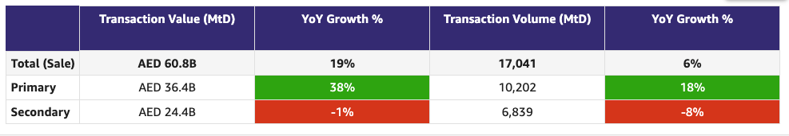

Commercial

Commercial
Category | DRI | Which metric is red and why | Actions planned | ETA for target achievement
Sales forecast % | Vladimir Malugin | Feb: Overall 88% (without Hamptons)  - Aqua landed at 55% increase vs a maintain opening  - Hamptons: Achievement moved to March while target stays in February due to 1 month contract extension.  - Paragon Properties: +8% increase on current base (vs 26% growth target) after super-challaning negotiations. Performing well as an Edge client, but unwilling to stretch further given perceived benefit realization  - Mega Homes FZC: Client maintained their spend vs 116% target after indication of downgrade. Historically conservative decision-making, with recent stronger conversion on Bayut  - DXB NB at 79% with slower DLD registrations - up from 65% earlier in the month  March previous view 95% (with upside to 101%)  CURRENT VIEW 72% FC for March (upside to 78%) - sales have identified main risks. Hostilities duration/situation easing will impact both risk + upside.  NB: Salesforce was down last week, resumed today (AWS ME outage) - working on securing March due payments and renewals due.  Current sentiment from clients - no panic, focusing on converting March deal pipeline, significant reduction in leads, concerns around cashflow for next few months (offers will help) | Continued focus on increasing sales through the following actions:  Short Term  - Bundles Launch in Q2  Medium Term  - Account Plans: Structured plans in place for key accounts to drive focused growth and retention - 90% competed in Diamond  - Renewal Narratives: Strong partnership with Commercial Analytics to build clear, data-backed renewal stories for Diamond and Ruby accounts - Aqua case in point  March MAIN RISK factors:  - Risk on upcoming and upsides & renewals - in both sentiment and execution  - Risk on mid-contract payment  MITIGATION:  - March Renewals: Bonus credits for 100% payment in the first month or 100% deferral option for the first month to be spread across the remaining contract  - New Business: 13 months worth of credits for 12 months payment for new business who has signed and paid but wants to cancel  - March Cycle Payment: 50% Payment deferral option for the month of March  - Relief on staying online this month for customers unable to perform payment  - Communication on payment relief and support from PF
Exclusive Listings | Michelle Brackley | Rebaselined data is available in the dashboard. We are currently working on data sanity check and will be re-running the target setting exercise this week  We are working with cross functional teams to achieve traction on the numbers but the numbers look to have inaccuracies which means it is difficult to make an impact or set target customers.  Looking to set “target customers” based on biggest gap by customer and communities. | Updates from last weekly meeting:  1. Non-Compliant Listings  • Baseline recalibration  Owner: BA team  Status: Done, data review in progress  • WA reminder to agents & admins  Owners: Pascal  Action: Working with Saif on this  ETA: Meeting on Wednesday  2. Automatic Import of BY Exclusive Listings on Expert  Owner: Hugs  ETA: 16th March  Dependency on DE team for daily scraping (vendor to be closed this week)  3. CPL Discount on BY Exclusive Listings  Owner: Anirudh  ETA: 9th April  4. Milestone-Driven Benefits (incl. SuperAgent Points – “First to PF”)  Owner: Hugs, Sajjad  Action 1: Hugs and Sajjad to design mock-ups  Dependency on DE team for daily scraping - Khaled to provide update  5. Compass Data Narrative  Owner: BA team  Action 1: Get the listings in Sales Compass  Action 2: March end for getting the narrative on Sales Compass  6. Community Performance Marketing  Action 1: Exclusive listings will be incorporated into the ranking methodology for "Top Communities"  Owner 1: BA Team  ETA 1: TBD  Action 2: Evaluate if campaigns can be conducted for communities with high Bayut exclusive listings and outside top 25 PF communities  Owner 2: Mahmoud  ETA 2: TBD  7. New Business SPIFF for Exclusive Listings  Status: Done  Owner: Commercial Strategy

Weekly Metrics
 |  | Weekly |  |  |  | MTD (Feb)
Category | Metric | Week  (Actual) | Week (Target) | WoW | vs 2 weeks prior | MtD  (Forecast) | Month (Target) | vs MtD  prev month (MoM) | vs MtD  prev year (YoY) | vs competition | DRI | Dash
Sales  (MtD) - UAE | Sales Forecast %  (Month-end) | Monthly -> |  |  |  | 55.3 M  (88.4%) | 62.6 M | Not Applicable | Not Applicable | Not Applicable | Vladimir Malugin | Link

CLEL to not be discussed in Q1, till baseline is defined and Product actions are in place

Category | Metric | Week  (Actual) | Week (Target) | WoW | vs 2 weeks prior | MtD  (Actual) | Month  (Target) | vs MtD  prev month (MoM) | vs MtD  prev year (YoY) | vs competition | DRI | Dash
Net exclusive listings | Rent | 2.7K | NA | -0.1K  2.8K | -1K  3.7K | NA | NA | NA | NA | Not Applicable | Michelle Brackley
 | Sale | 13K | NA | +0.7K  12.3K | +0.6K  12.4K | NA | NA | NA | NA | Not Applicable | Michelle Brackley
Supply | Net Exclusive Listings | 15.7K | NA | +0.6K  15.1K | -0.4K  16.1K | NA |  | NA | NA | Not Applicable | Michelle Brackley
 | Total Listings | 375.1K | NA | -4.8K  379.9K | -3.2K  378.3K | NA | NA | NA | NA | -139.2K  514.3K
 | Dubai | 219.6K | NA | -2K  221.6K | -0.6K  219K | NA | NA | NA | NA | -4.9K  224.5K
 | Abu Dhabi | 16.7K | NA | -0.1K  16.8K | -0.4K  17.1K | NA | NA | NA | NA | +1.7K  15.0K
 | Northern Emirates (incl Al Ain) | 138.8K | NA | -2.8K  141.6K | -1.4K  140.2K | NA | NA | NA | NA | -136.0K  274.8K

Primary (NP, Media, Dev)

Primary (New Projects, Media Sales)
Category | DRI | Which metric is red and why | Actions planned | ETA for target achievement
New Projects | Enguerran Milhiet | - Sessions (red): achieved 88% (vs 90% expected). Same narrative: delay in the launch of SEO and performance marketing initiatives.  - Sold leads: achieved 98% (vs 95% expected). Impact of lower sessions (see above) over-compensated by better conversion.  - Gross revenue: 22% above target. Slight under-achievement on sold leads (see above) over-compensated by higher average selling price (change in product to push higher CPL projects up + commercial push).  - YTD gross revenue: 124%  - 82% of Q1 target achieved. | Ongoing:  - Accelerated SEO initiatives (Community reviews, internal links, Googlebot).  - Optimise performance marketing campaigns (already happening). | - March will be in red (impact of the conflict). We are re-assessing targets.
Media & Developers | Sami Awada | - Sales overachieved by 56% in February (Aldar contract for 1.8MAED, i.e. ~50% of the achieved sales).  - YTD: 24% above sales target | Since a few campaigns have been paused, we have redirected all traffic to the active campaigns to accelerate delivery. We are still waiting for the updated impression and lead counts from AdOps to assess the impact. | - March is currently in the red as of today, with a forecast of 29%. Several deals remain on hold due to the current circumstances; however, we are still receiving briefs for upcoming campaigns.

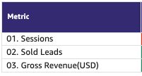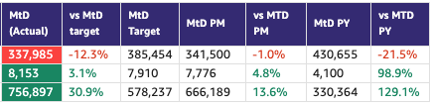
02. Sold Leads | 7,729 | -2.3% | 7,910 | 8,442 | -8.4% | 3,812 | 102.8%
03. Gross Revenue (USD) | 707,387 | +22.3% | 578,237 | 721,795 | -1.9% | 299,066 | 136.5%
Sales from Media Products | 993,460 | +56% | 636,407 | NA | NA | NA | 96%

Demand (Paid/Unpaid)
f
Demand
Category | DRI | Which metric is red and why | Actions planned | ETA for target achievement
Paid | Ahmed Osman | - Web Paid Listing Leads: Below target as we’re seeing a massive increase in non-listing leads. | - Marketing, BA, DE & MarTech to work on defining the problem statement and how to ensure consistency in measuring leads moving forward across both web & app.
Unpaid - SEO | Mahmoud Nessim | - SoS, is at 47.4% which is 1.6 P.P MoM, but 1.2% from the monthly target.  - Buy SoS, is reaching an all time high 61.3% since 2025.  - Rent is still what drags is down ( 42.2%, and anyways +0.6pp)  - SoV is trending upward to all time high ~ 46.5% ( having some issues with the tracking tool currently fixing ) | Actions Taken to Drive These Results  Content Optimization  - Defined the ideal page anatomy per page type based on competitor and in-house entity analysis, tested and validated the model.  - Scaled content output from 40-60 to ~150 pieces per month via an MVP AI automation pipeline, human in the loop.  - Prioritized high-impact pages using a content decay and opportunity matrix, scoring pages with strong listings and impressions but weak rankings due to missing core entities.  Internal Linking  - Built a matching algorithm connecting blogs and insights, leveraging UGC to drive insights visibility. Daily clicks jumped from ~160 to 300+.  - Revamped Home Page internal links.  PLP Translation  - Showing positive movement on CTR and ranking positions ( +8% and +2% respectively )  SEO Indexation Health  - Indexation score up from ~79% to 86%.  Actions Planned to Grow Further  - Rent gap: identified key communities with supply shortfalls, working with Michelle Brackley to secure supply. Active conversation this week.  - UGC: going all-in for March and Q2. Launching UGC reviews on SERPs and PLPs this week with internal GTM, external and offline GTM by Q2.  - Quick wins: pagination fix for crawlability, CSR fix for new project cards on SERPs, translations rollout to all listings. | - UGC reviews on SERPs and PLPs: this week  - Internal GTM for UGC: Mid March 2026  - Supply Actions with Michelle Brackley: ongoing, this week  - External and offline GTM for UGC: Q2  - Pagination fix: Mid March  - CSR fix for new project cards: Mid March  - Translations rollout to all listings: Mid March
Unpaid - Overall | Soumar Aoun | - App is green 🟢  - Web direct is still being fixed under data governance. | This week’s update:  Ramping up (experiments → scale)  - 2D Floor Plans (App + Web) — Ramped up to 100%  - PLP Revamp (Desktop + App) — Ramped up to 100%  - Scarcity Tag (“High demand!”) (Web) — Ramped up to 100%  Shipping this week (structural impact)  - SERP Revamp (Web) — 13/3  - Enabling Search Re-engagement for New Projects — 13/3  - Revamp of the “Enable Notifications” In-App Modal — 13/3  Delayed / shifted  - CTAs on Recommended Properties on PLP (Web) — Delayed due to priority shift (Pro bundles ranking boost logic + Location Tree fixes). Updated launch: 13/3  Ramped Down (CRM)  - Saved Properties & Saved Alert Push + Emails — Halted due to CRM ramp down  - Push Notification Content Revamp (Travel Times, Saved Search, Saved Property) — Halted  - Valuation Feature Visibility — Push notifications halted  - Travel Times Feature Visibility — Push notifications halted  - Saved Search & Saved Properties — Email + push notifications halted | N/A
Exposure LPL | Paresh Goyal | - Buy LPL  - Same reasons as last time  - Not a concern as no increased noise from clients regarding RoI | - As discussed last time, this is expected to continue being in red for the reasons mentioned  - Q2 eLPL targets to be reset to align with actual market growth (Ashish)  - Most marketing activities are on pause, given the current situation (Ahmed).  - Search Re-engagement - Biased Exposure Listings (Live ETA: 30th Mar)  - Push and Email  - Top Picks (targeted recommendation) (Live ETA: 30th Mar for web only; 13th April for app - to be confirmed)  - Push & Email
Leads click to delivered | Sruthi Poduval | - CTD - WA on target  - % increase in error leads from 4.8 - 6.3%  - Visible co relation to the increase in spam traffic from +91, +92 numbers | - Spam leads workstream in progress  - Error leads re engagement flow - PN | - Both initiatives planned for delivery by 27/3

Competition:

1. Share of Sessions
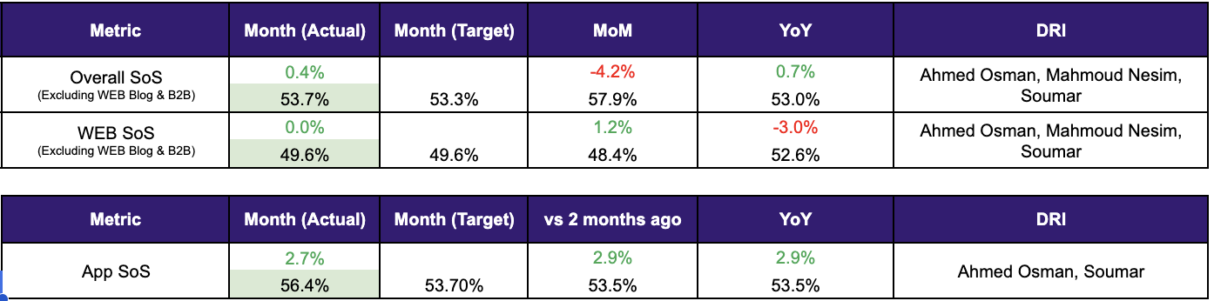

2.1 Web

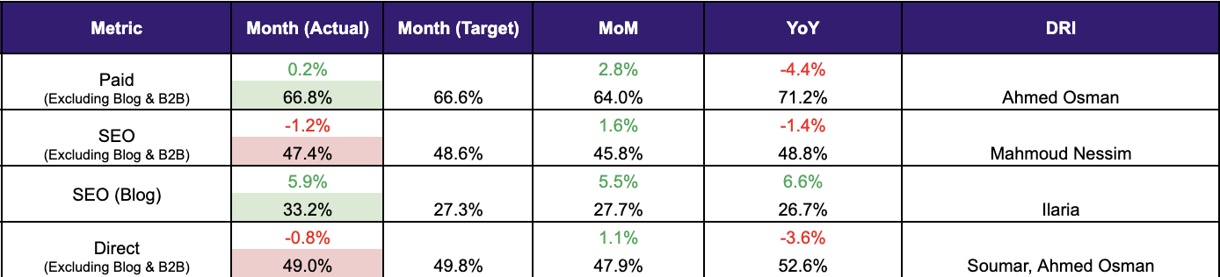

2.2 App

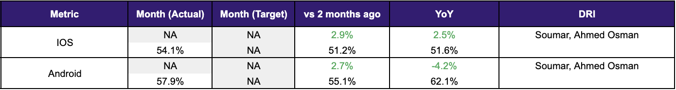

2. SoV - SEO

Metric | MtD (Actual) | MtD PM | vs MtD PM
Total | 41.6% | 41.6% | -0.04
Buy | 66.1% | 66.0% | 0.11
Rent | 48.0% | 49.6% | -1.61
Generic | 29.4% | 28.2% | 1.20

2. Demand Funnel
(Direct and SEO Data are currently being fixed under Data Governance Workstream)

Web - Paid
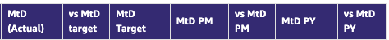
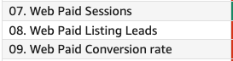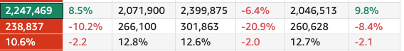

App - Total
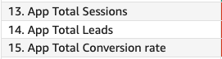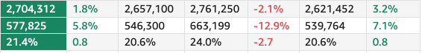

Exposure LPL
(EXCLUDES DIRECT)

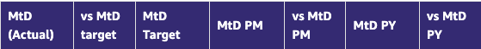
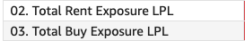

Leads and Listings distribution

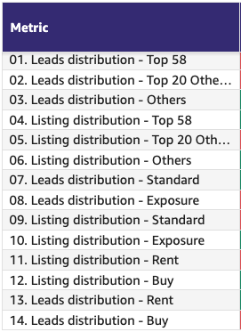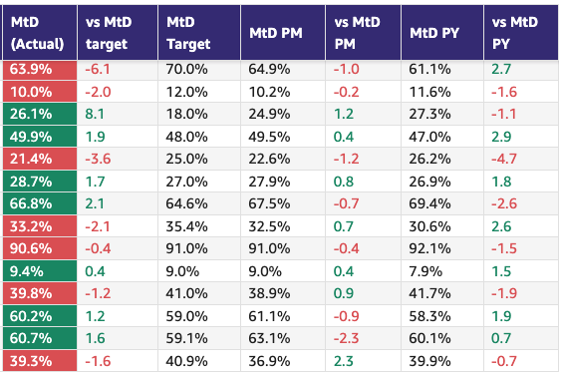

Rent vs Buy Split

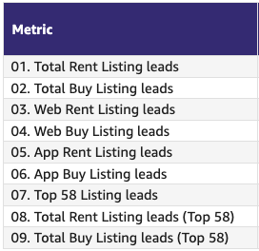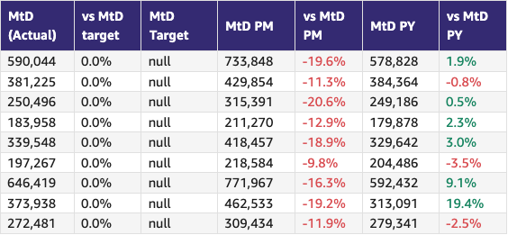

Monthly Metrics

B2C NPS
Category | Metric | MtD  (Actual) | Month (Target) | vs MtD  prev month (MoM) | vs MtD  prev year (YoY) | vs competition | DRI | Dash
B2C NPS | B2C NPS | 4 | Not Available | 3 | 19 | Not Available | Alson Dsouza

Leads click to delivered:
Category | Metric | MtD  (Actual) | Month (Target) | vs MtD  prev month (MoM) | vs MtD  prev year (YoY) | Δ vs Competition | DRI | Dash
Leads Funnel | Total Leads Delivered (WA) | 616k | 653k | 742k | 579k | Not Available | Soumar AounSruthi Poduval | Link
 | % Clicks to Delivered (WA) | 84.6% | 84.3% | 87.8% | 81.6% | Not Available | Soumar AounSruthi Poduval | Link
 | Error Leads (WA) | 6.3% | 4.8% | 5.3% | 5.5% | Not Available | Soumar AounSruthi Poduval | Link

PR Metric
Category | Metric | MtD  (Actual) | Month (Target) | vs MtD  prev month (MoM) | vs MtD  prev year (YoY) | vs competition | DRI | Dash
PR | PR Sov | 85.4% | 50-55% | +23% | [...] | [...] | Natalie Faulkner | PR team

- Competition
  - Share of Session (Overall, Web Channels, App Channels)
  - SoV - Paid click share

- Demand Funnel
  - Sessions (by channels)
  - Leads (by channels)
  - CR (by channels)
  - Click to Delivered

- Exposure LPL
  - Overall / Rent / Sale
  - Top Communities
  - Web/App
  - Exposure Leads as % of Total Leads (Overall / rent / sale)
  - Exposure Listings (Overall / rent / sale)

- Engagement Metric (Time on site)

Platform | Company | Month (Actual) | vs MtD  prev month (MoM) | vs MtD  prev year (YoY) | DRI
WEB |  |  | 0% | -8% | Soumar
 | PF | 04:40 | 04:40 | 05:05
 |  |  |  |  | Soumar
 | Bayut | 03:36 | 03:22 | 03:56
App |  |  | -10% | -1% | Soumar
 | PF | 1.13 | 1.26 | 1.14
 |  |  |  |  | Soumar
 | Bayut | 1.12 | 1.28 | 1.19

- B2C NPS - In line with recent months trend. Top negative comments continue to be around responsiveness and interaction with the agent (23%), listing accuracy (availability, images and prices) (17%) with platform usability and performance (15%) rounding off the top 3 reasons for detraction. Tracking compliance initiatives launched this month should in theory have a positive impact on NPS. Point to note, these initiatives are still reactive in nature so consumers will still face the problems they complain about.
- PR SoV - we are way ahead of the competition in terms of SoV - thanks to a number of press stories, including mention in Stake’s series B financing announcement.
- Leads split by Rent vs Buy

Data Governance

DATA GOVERNANCE
Problem Name | Problem Description | Latest update | Resolution update (ETA) | DRI
Spam Issues | Unrealistic spike on sessions and lead clicks since September 2025  Reported delivered spam leads from Pakisting and India | 1 Remove spam activity from all reporting tables across both GA4 and Snowplow leveraging third party tool (Cheq) - almost completed  2 Define tech solution to block “bad” spam activity so it can be prioritized during Q2 roadmap planning - work in progress (delayed)  3 Define short term solutions to decrease noise around spam delivered leads  Action 3.1: mark as spam without Attempt ID from IN/PK - work in progress (on track)  Action 3.2: leverage crowdsourcing from agents to mark phone numbers and leads as spam - work in progress (on track)  Action 3.3: block selected list of phone numbers from IN/PK based on historical performance - work in progress | 1 - 10/03  2 - No ETA (delayed)  3.1 End of March  3.2 End of April (tentative)  3.3. 10/03 | 1. Wael AbdellaAamir Shaiq  2. Amory Kelie  3. Sruthi Poduval
SEO (Sessions vs clicks) | SEO session not fully in line with Google Search console clicks | 1 Agreed on starting reporting SEO traffic as-is once spam activity is removed - almost completed | 1 - 10/03 | Aamir ShaiqWael Abdella
CRM Attribution Reporting | CRM sessions not in line with braze clicks | 1 Initial assessment completed for push notifications and 2 potential drivers identified:  - Channel attribution was only triggered once a lead is created - completed  - Last touch non-direct logic only applicable after 24 hours for app (discrepancy with web logic) - under discussion (delayed) | No ETA | Wael SalloumAhmed Osman
Kochava Integration Update | Integration between Kochava and PF pipelines unstable | 1. Upgrade integration between Kochava and PF Expert - completed  2. Back-fill specific dates in January were we saw a drop - work in progress | 1 - 10/03  2 - 06/03 | Uday Kasetty
Non listing Leads | Spike on non-listing leads starting in January driven by lack of synch between old/new listing service during portal DB migration | 1. Web - completed  2. App - Work in progress  3. Overall reclassification of leads - work in progress | 1 - completed  2. - No ETA  3 - No ETA | Aamir Shaiqand Mahesh Maheswaran
Credit consumption | 1 - Significant decline on credit spend in January and August  2 - 1-2% of “credit consumption” against listings that “never went live”  3 - Some of spotlight listings are not flagged as spotlight | 1 - completed  2 - work in progress  3 - completed | 1 - completed  2 - No ETA  3 - completed | Ahmed Malikand Aamir Shaiq

B2C App Engagement

B2C App
Category | DRI | Which metric is red and why | Actions planned | ETA for target achievement
App engagement & installs | Ahmed Osman | - Green. | - ASO: A complete refresh of app screenshots is planned by next week to reflect new app USPs and a new creative theme (Group level).  - Paid UA: Planned activities for the remainder of Q1, focused on more diversified messaging (HV, My Activities, New Simplified UI). Activities to resume upon the current geopolitical crisis are mitigated. | - N/A
App ratings | Soumar Aoun | - Rating dropped to 4.03 (now recovering to 4.07). Main drivers: (1) Google removing previously solicited ratings after policy threshold breach, causing a delayed decline. (2) A specific app version 13.44.0 generating lower ratings (~3.6 vs 4.2 last 30 days). (3) Recent app performance degradation impacting perception: perceived crash rate 0.23% vs 0.12% rolling avg, perceived ANR 0.18% vs 0.11% rolling avg. BA analysis shows correlation between app performance and ratings. | - Keep rating solicitation slow to avoid further Google penalties.  - Focus on app performance improvements (crash rate, ANR, slow cold start) rather than AppDex alone.  - Elevate team analyzing Android performance regressions and rolling fixes.  - Extend trigger timing for rating prompts to prioritize genuine satisfaction signals. | - Recovery expected gradually over the next 1–2 quarters due to Google’s 30-day rating calculation window. 4.5 target unlikely this quarter; proposing sustainable growth approach instead of aggressive solicitation.

Weekly Metrics -

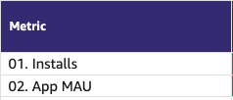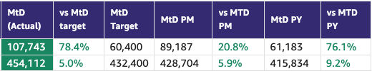

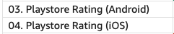

App ratings

- App Installs
- App MAU
- DAU/MAU
- Sessions / DAU
- Login Ratio
- Avg Session Duration
- Playstore rating (Android)
- Playstore rating (iOS)

B2C Tech Metrics

B2C App
Category | DRI | Which metric is red and why | Actions planned | ETA for target achievement
App stability & performance | Taran Kambow | Android: Issues Identified across Network, App hangs during last month  iOS: Luciq SDK upgrade on Jan 30th led to increased app hangs and force restarts. | Android: Issues identified and fixed.  iOS: Version rolled back and hotfix deployed on Feb 13th with adoption taking the score towards target. Another root cause identified - Google Ads on Search - testing under progress. | Fix to be deployed on Mar 18th post testing
Web Stability & Performance | Amory Kelie | - Mobile INP Good Rate improved to 70.2% (+1.1pp WoW) but remains below the 72% target.  - Improvement is driven primarily by performance gains on the Search Results template, which showed a ~27% latency improvement.  - Property Listing Pages remain stable and performant (~41% of interaction volume).  - Some volatility remains on Search Landing Pages and long-tail templates, which we continue to monitor. | Continue stabilizing Search Landing and Results templates, which together represent ~35% of interaction volume.  Audit recent JS, experiment and tag injections impacting interaction latency.  Enforce performance budgets on high-traffic templates.  Maintain daily monitoring of INP across top interaction surfaces. | - End of Q2

 |  | Weekly |  |  |  | MTD
Category | Metric | Week  (Actual) | Week (Target) | WoW | vs 2 weeks prior | MtD  (Forecast) | Month (Target) | vs MtD  prev month (MoM) | vs MtD  prev year (YoY) | vs competition | DRI | Dash
Tech stability & Performance | Mobile INP Good rate (%) | 70.2 | 72% | +1.1 | +0.7 | 69.8 | 72 | -0.3 | NA | NA | Amory Kelie

- Appdex: Android
- Appdex score: iOS
- CWV

B2B Product

B2B
Category | DRI | Which metric is red and why | Actions planned | ETA for target achievement
CSAT (P0s) | Luis Cappa | We closed February with the lowest incident volume (P0 + P1) in the last two years: 3 P0s and 40 P1s across five teams.  This translates into a sustainable operational load of 8.6 tickets per team per month, or 2.15 tickets per team per week. | N/A | N/A
Agent Experience | Sajjad Ahmad | We are behind on our rollout schedule for Buyer Claims (new feature in agent app). | Accelerating the rollout of Buyer Claims in March H1 (having beta tested, and scaling to more clients)

Weekly Metrics
 |  | MTD
Category | Metric | MtD  (Actual) | Month (Target) | vs MtD  prev month (MoM) | vs MtD  prev year (YoY) | vs competition | DRI | Dash
CSAT | Incident Volume | P0: 3  P1: 40 | P0: 6  P1: 73 | P0: 5  P1: 62 | P0: 5  P1: 60 | Not Available | Luis Cappa | Link  (JIRA)

Agent Engagement & Experience | App active agents | 11,105 | -8%  12,197 |  | Not Available | Not Available | Sajjad Ahmad
 | Active users per week (WAU) | 3,588 | -15.5%  4,245 |  | Not Available | Not Available | Sajjad Ahmad
 | Agent NPS | Monthly Metric |  |  |  |  | Sajjad Ahmad

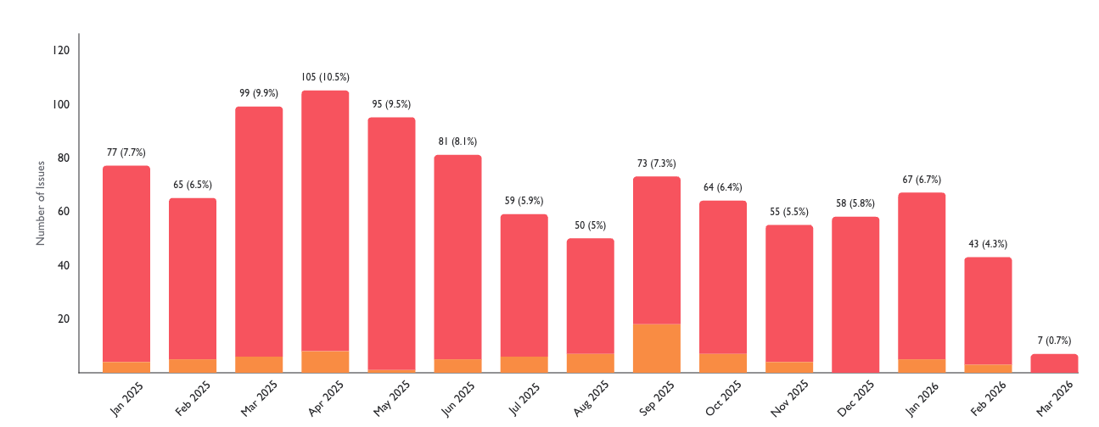

Listing Quality

Monetization
Category | DRI | Which metric is red and why | Actions planned | ETA for target achievement
Compliance | Saif Al-Amid | - Latest weekly metric in green, actions underway for cleanups.  - Additionally we have released a number of features to mandate validation:  - Primary vs secondary  - Offering type and property type nightly check  - Adrec offering type  - Location suggestion (PF expert) | - We have restarted the clean up exercise from Monday this week after a pause due to the geo-political situation (note we still have some issues with locations mapping).  - Size mandation (residential units only)  - Locations validation (within accurate locations only)  - Review client-based exceptions  - Phase 1 Reducing API hits | - Clean up: we will continue this week  - Size mandation: 31st March  - Locations validation: 23rd March  - Review client-based exception: Wednesday 11th March.  - Phase 1 Reducing API hits for nightly check by 80% = 31st March
Quality Score | Huguette Bukasa | - Metric in green
Availability % | Shradha Mohanan | - Metric in green | - Availability score to be incorporated into QS score in Q2.  - Additional initiatives outside of the model included as part of fake listings.

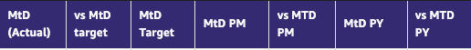
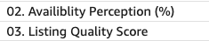

Special Projects
Monthly Lookbacks

Converting at risk clients to Promoters Ivan Gregorc Status
- Expected achievement at the end of the quarter. Based on current progress, what’s the estimated achievement rate for the end of Q1 2025?
By end of Q1, we expect to convert 50%+ of Neutral/Detractor clients into Promoters (target= 15 promoters) and protect renewal risk across the Marketing-owned portfolio (20 clients). Assuming delivery on Product-dependent items.
Current status: 🟢Promoters: 9 🟡Neutral: 9 🔴Detractors: 2
- Achievement (till date) : Indicate completed and pending tasks.
- Client sentiment baseline established and tracked weekly
- Identified top 6 elements to turn Neutral clients into promoters
- Active engagement in place for all Target clients
Pending:
- Impediments : If applicable, what is delaying the progress?
- The majority of blockers are Product-dependent
- Some perception issues (Awards, Premium value) require time and repetition to shift
- Initiatives to address impediments: What actions will we take to address the above issues or improve results?
- 5 out of the 6 (SuperAgent Point System, Spam Leads, Split Deals, Agent Engagements,, Cost of Premium Listings) major issues brought up are being addressed by end March
- 1 out of the 6 (Draft listings Listings) was addressed
Link to deep dive document

Special Projects - Q1 OKRs
Keyper Soumar Aoun On Track
- Expected achievement at the end of the quarter. Based on current progress, what’s the estimated achievement rate for the end of Q1 2025?
  - Keyper integration across B2B and B2C flows is in progress, with the majority of core components in active development and the remaining work focused on final CX workflow alignment and commercial enablement.
Core integration is on track for completion by the end of March. A buffer period for end-to-end testing and launch readiness will follow, with go-live expected no later than 15 April 2025 with overall progress reaching ~95% completion by the end of Q1 2025.
- Achievement (till date) : Indicate completed and pending tasks.
  - 3 agencies selected for MVP launch
  - ~50% of Keyper implementation delivered and the rest is under progress
  - The CX team is working towards a joint CX workflow plan with Keyper.
  - Legal review of key agreements within the flow is ongoing.
- Impediments : If applicable, what is delaying the progress?
  - Design and development capacity constraints have impacted the pace of the integration.

- Initiatives to address impediments: What actions will we take to address the above issues or improve results?
  - Additional contractors onboarded to the B2C team to increase capacity and accelerate delivery
  - Prioritization of core integration components to ensure critical functionality is delivered on schedule

Bundles Paresh Goyal On Track
- Expected achievement at the end of the quarter. Based on current progress, what’s the estimated achievement rate for the end of Q1 2025?
  - MVP Product will be ready for launch in March
  - Pilot sales has been intentionally pushed out, given current market and client situation
- Achievement (till date) : Indicate completed and pending tasks.
  - Development work progressing on-track but with some impact from salesforce migration
- Impediments : If applicable, what is delaying the progress?
  - Salesforce system has just come back online and hence, salesforce development work had paused
  - Expected impact of 2-3 days in completing salesforce development and hence, delay in go-live from 24th March to 26th March
- Initiatives to address impediments: What actions will we take to address the above issues or improve results?
  - Working towards an approach to sign paper contracts for bundles and a potential way to manually switch on bundles for such clients

📋 Prev Saved Reports

Week | Date | Link
Week 8 | Feb 16 to Feb 22 | WBR - Week 8 (Saved Report) Metric Report
Week 7 | Feb 9 to Feb 15 | WBR - Week 7 (SAVED) Metric Report
Week 6 | Feb 2 to Feb 8 | WBR - Week 6 (Saved) Metric Report
Week 5 | Jan 1 to Jan 31 | WBR - Jan Monthly Lookback (Saved Report) Metric Report
Week 4 | Jan 19 to Jan 25 | WBR - Week 4 (Saved) Metric Report
Week 3 | Jan 12 to Jan 18 | WBR - Week 3 (SAVED) Metric Report
Week 2 | Jan 5 to Jan 11 | WBR - Week 2 (SAVED) Metric Report
Year End.
W52 | Dec 1 to Dec 30 | WBR Metric Report - Dec Monthly Lookback (Saved Report)
W49 | Dec 1 to Dec 7 | WBR Metric Report - Week 49 (Saved Report)
W48 | Nov 1 to Nov 30 | WBR Metric Report - Week 48 - Nov Monthly Lookback (Saved Report)
W47 | Nov 17 to Nov 23 | WBR Metric Report - Week 47 (Saved Report)
W46 | Nov 10 to Nov 16 | WBR Metric Report - Week 46 (Saved Report)
W45 | Nov 3 to Nov 9 | WBR Metric Report - Week 45 (Saved Report)
W44 | NA | NA
W43 | Oct 1 to Oct 31 | WBR Metric Report - Week 43 - Oct Monthly Lookback (Saved Report))
W42 | Oct 15 to Oct 21 | WBR Metric Report - Week 42 (Saved Report)
W41 | Oct 8 to Oct 14 | WBR Metric Report - Week 41 (Saved Report)
W40 | Oct 1 to Oct 7 | WBR Metric Report - Week 40 (Saved Report)
W39 | Sep 1 to Sep 30 | WBR Metric Report - Week 39 (Saved Report)
W38 | Sep 17 to Sep 23 | WBR 2.0 Report - Week 38 (Saved Report)
W37 | Sep 10 to Sep 16 | WBR 2.0 Report - Week 37 (Saved Report)
W36 | Sep 3 to Sep 9 | WBR 2.0 Report - Week 36
W35 | Aug 1 to Aug 31 | Copy of WBR 2.0 Report - Week 35.docx
W34 | Aug 20 to Aug 26 | Copy of WBR 2.0 Report - Week 34.docx
W33 | Aug 13 to Aug 19 | WBR 2.0 Report - Week 33.docx
W32 | Aug 6 to Aug 12 | Copy of WBR 2.0 Report - Week 32.docx
W31 | Jul 30 to Aug 5 | WBR 2.0 Report - Week 31.docx

